Experiment Tracking Conceptual Design - Final Project 3
- Experiment Objectives: - Collin
For our experiment, we want to compare a few different binary classification models, like logistic regression, decision trees, and/or random forest to see which one performs the best for predicting customer churn. Since our data set and problem aren't overly complex, these models provide a strong starting point for comparison. The goal is to not only figure out which models perform well but is also easy to work with and makes the most sense for us moving forward. We also want to evaluate how effective our preprocessing steps are, since cleaning and prepping the data will impact the results. Overall, we are trying to build a process that is reproducible and easy to tracking order to support model selection for the MVP Phase.

- Key Components to Track: Brad
For our experiment tracking, we want to log enough detail to compare runs and reproduce results without overcomplicating things. For metadata, we would include a clear run name, a short description of what changed (model, preprocessing, tuning), the date and time, dataset version, and whether the run is training or testing. This keeps everything organized and easy to compare. For the training data, we would track all preprocessing and feature engineering steps to make sure results are consistent. This includes how we handle missing values, how we treat categorical vs numerical variables, any columns we include or exclude, and whether scaling or normalization is applied. Since we are using the Telco churn dataset, this helps ensure we are not comparing models built on slightly different data. In terms of models, we would test logistic regression, decision tree, and random forest. For each, we would track key hyperparameters like regularization (logistic regression), max depth and split criteria (decision tree), and number of trees and max depth (random forest) so we understand what is driving performance. For evaluation, since this is a classification problem, we would focus on recall and precision, along with F1 score to balance both. We would also track feature importance, model version, and performance across runs to see what is improving over time. All experiments will be tracked using MLFlow to log parameters, metrics, and artifacts.

- Outcome Goals: - Thomas
The primary success criterion for this experiment phase is identifying a model that achieves strong recall on the positive churn class, meaning the model correctly flags the majority of customers who will actually churn. Precision will serve as a secondary constraint, ensuring that flagged customers represent a reasonable proportion of true positives and that retention resources are not spread too thin. A model will be considered viable when it demonstrates a meaningful improvement in recall over a logistic regression baseline while maintaining acceptable precision, with AUC-ROC used as a summary of overall separability.
Experiments will be compared using MLFlow to log parameters, metrics, and artifacts across model runs, providing a centralized record of what was tested and how each configuration performed. A model will be considered ready for the MVP phase if it meets the defined recall and precision thresholds on held out test data and its results are fully reproducible via the versioned dataset and logged MLFlow run.

- Diagram/illustrations - Michael
Let me start with the overall build plan. We have several pieces yet to solidify but some experimentation has started. Our plan is laid out at a high level in the following chart. We will move through the steps in a methodical manner trying to incorporate validation in every step along the way.

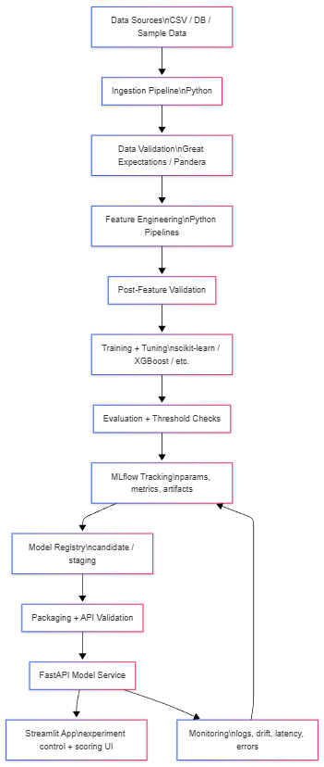
The complete toolkit is still under evaluation but some components seem clear. At a high level we will use python via VScode as the primary starting point. As with all great ML work, we will be using SciKit, Evidently, Pandas, and likely Great Expectations. At the moment, we are leaning to use pandera for validation. Using MLFlow, we will capture the results of training. Finally, we will use streamlit and fastapi to demonstrate our solution.
We have already completed this activity a few times with various experimental models as shown in the snips included below. MLFlow seems to be a very capable tool for capturing and recording the experiments and models for long term version management.

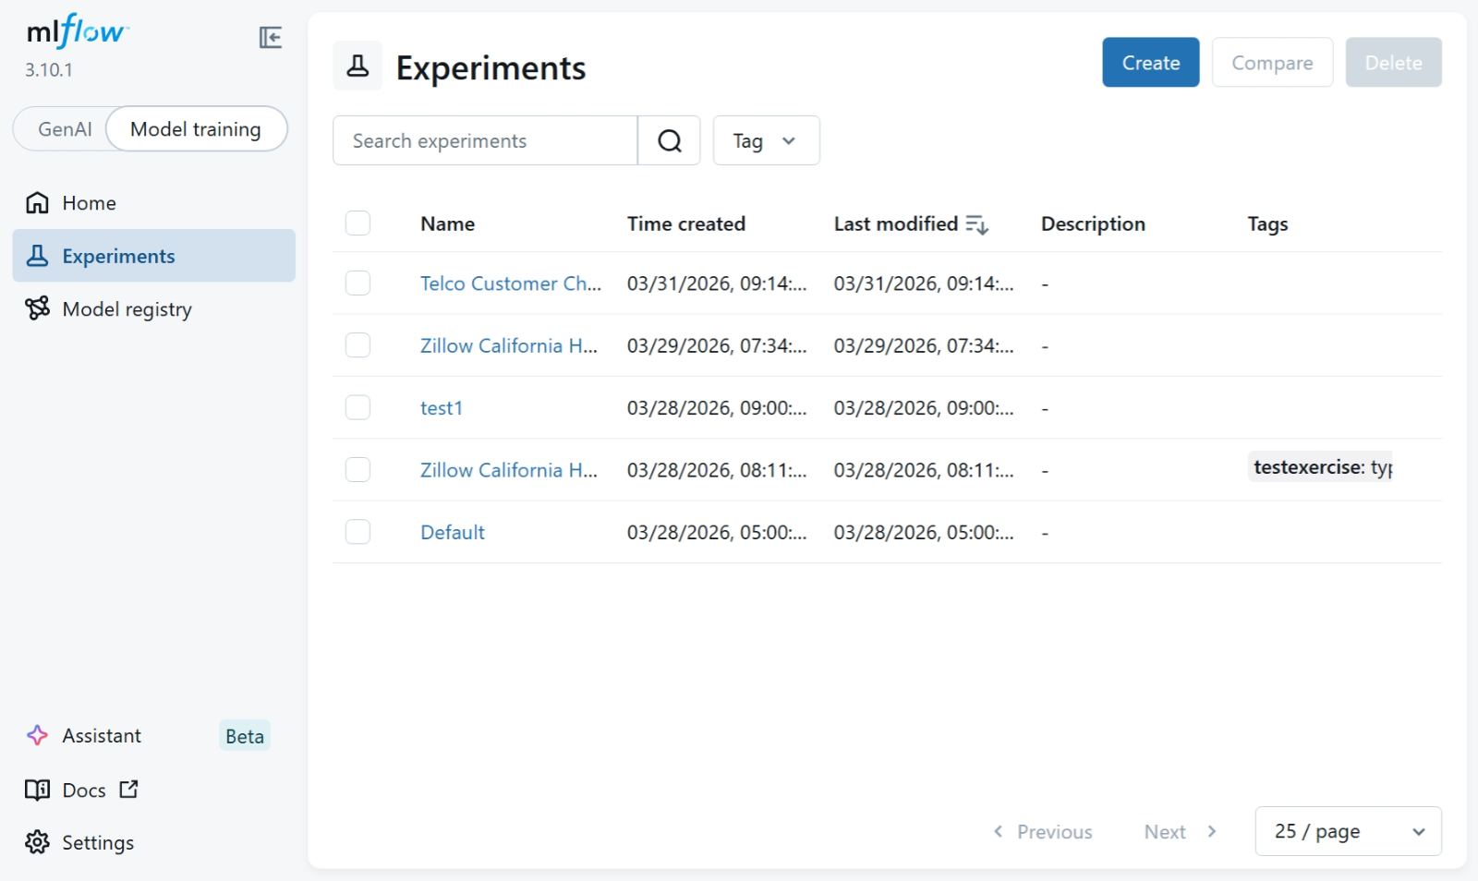
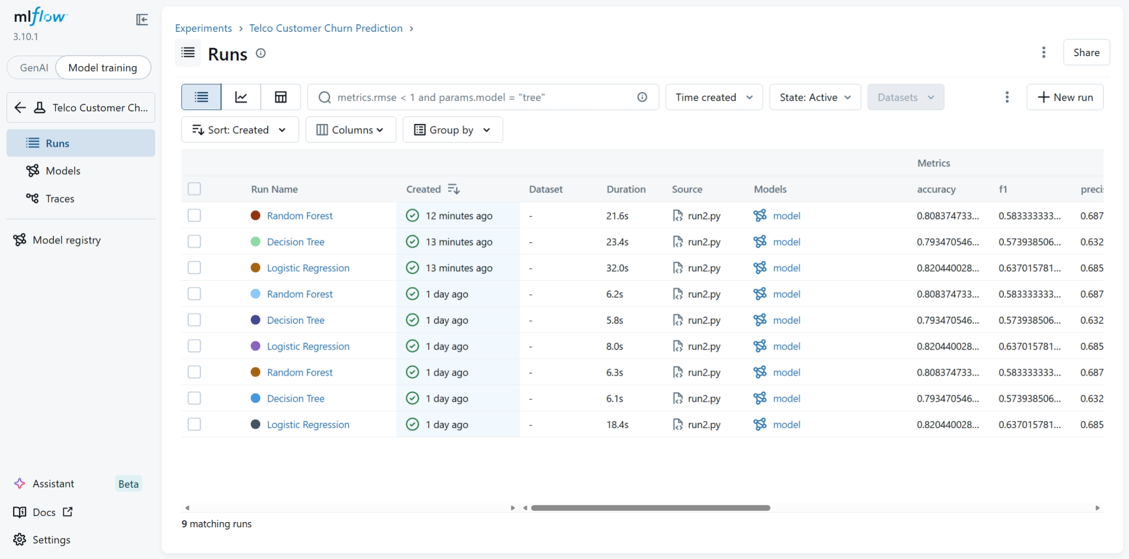

Considering we are only 50% through the course, this is about as far as we have got.
We have started some additional experimentation with fastapi and streamlit to expose our api and display a web page to test some scenarios of modified attributes.
See page capture below.
